# Report 3: System Requirements Specifications (SRS)

## 3.2. System Requirement Specification

### 3.2.1. External Interface Requirements

### 3.2.2. Functional Requirements

### 3.2.2.1. Functional Requirement 1 - Add new Patient

### 3.2.2.2.1. Use Case-1 Diagram

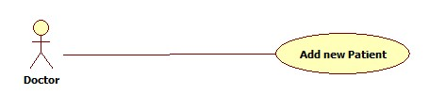

### 3.2.2.2.2. Use Case-1 Specification

|  |  |  |  |  |
| --- | --- | --- | --- | --- |
| **USE CASE - 5 SPECIFICATION** | | | | |
| **Use-case No.** | UC_001 | **Use-case Version** | | **1.0** |
| **Use-case Name** | Add new Patient | | | |
| **Author** | DanhTC | | | |
| **Date** | 30/05/2014 | **Priority** | Normal | |
| **Actor:** Doctor  **Summary:** This use case is doctor add a new patient.  **Goal:** Doctor can add a new patient.  **Triggers:** Doctor clicks “Add new Patient**”** button on **Doctor Profile** page.  **Preconditions:** User must be logged - in as “Doctor”.  **Post-Conditions:** If success:  A new patient is created in the system.  If failure:  The doctor is presented with an error message.  **Main Success Scenario:**   |  |  |  | | --- | --- | --- | | Step | Actor Action | System Response | | 1 | User logged – in as “Doctor” and clicks “Add new Patient” button on **Doctor Profile** page. |  | | 2 |  | Display “Add new patient” page with fields to add. | | 3 | Input suitable fields and click “Add new Patient” button. |  | | 4 |  | Validate input data.  Display message “Add new patient successful” and save data to database. |   **Alternative Scenario:** Exit criteria from main flow: 4 validate input data fails, display “Add new patient fail”.  **Exception:**   * When internet connection has problem, the system will ask user for trying again. * Identity Card has been existed.   **Relationship:** N/A  **Business Rules:** N/A | | | | |

### 3.2.2.2. Functional Requirement 2 – Update medical profile

### 3.2.2.2.1. Use Case-2 Diagram

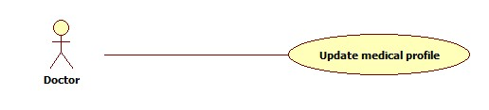

### 3.2.2.2.2. Use Case-2 Specification

|  |  |  |  |  |
| --- | --- | --- | --- | --- |
| **USE CASE - 5 SPECIFICATION** | | | | |
| **Use-case No.** | UC_002 | **Use-case Version** | | **1.0** |
| **Use-case Name** | Update medical profile | | | |
| **Author** | DanhTC | | | |
| **Date** | 30/05/2014 | **Priority** | Normal | |
| **Actor:** Doctor  **Summary:** This use case is doctor update medical profile.  **Goal:** Doctor can update medical profile.  **Triggers:** Doctor clicks “Update medical profile**”** button on **Doctor Profile** page.  **Preconditions:** User must be logged - in as “Doctor”.  **Post-Conditions:** If success:  A new patient is updated in the system.  If failure:  The doctor is presented with an error message.  **Main Success Scenario:**   |  |  |  | | --- | --- | --- | | Step | Actor Action | System Response | | 1 | User logged – in as “Doctor” and clicks “Update medical profile” button on **Doctor Profile** page. |  | | 2 |  | Display “Update medical profile” page with patient’s fields has been added to doctor can edit and update. | | 3 | Input suitable fields want to update and click “Update medical profile” button. |  | | 4 |  | Validate input data.  Display message “Update medical profile successful” and save data to database. |   **Alternative Scenario:** Exit criteria from main flow: 4 validate input data fails, display “Update medical profile fail”.  **Exception:**   * When internet connection has problem, the system will ask user for trying again.   **Relationship:** N/A  **Business Rules:** N/A | | | | |

### 3.2.2.3. Functional Requirement 2 – Update medical profile

### 3.2.2.3.1. Use Case-2 Diagram

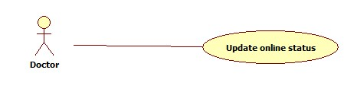

### 3.2.2.3.2. Use Case-1 Specification

|  |  |  |  |  |
| --- | --- | --- | --- | --- |
| **USE CASE - 5 SPECIFICATION** | | | | |
| **Use-case No.** | UC_003 | **Use-case Version** | | **1.0** |
| **Use-case Name** | Update online status | | | |
| **Author** | DanhTC | | | |
| **Date** | 30/05/2014 | **Priority** | Normal | |
| **Actor:** Doctor  **Summary:** This use case is doctor update online status.  **Goal:** Doctor can update online status.  **Triggers:** Doctor clicks “Update online status**”** button on **Doctor Profile** page.  **Preconditions:** User must be logged - in as “Doctor”.  **Post-Conditions:** Change status doctor  **Main Success Scenario:**   |  |  |  | | --- | --- | --- | | Step | Actor Action | System Response | | 1 | User logged – in as “Doctor” and clicks “Update online status” button on **Doctor Profile** page. |  | | 2 |  | Display drop down list of status such as: online, offline, busy to update online status. | | 3 | Choose online status. |  |   **Alternative Scenario:** N/A  **Exception:**   * When internet connection has problem, the system will ask user for trying again.   **Relationship:** N/A  **Business Rules:** N/A | | | | |

### 3.2.2.4. Functional Requirement 4 – View medical profile

### 3.2.2.4.1. Use Case-4 Diagram

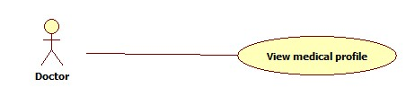

### 3.2.2.4.2. Use Case-1 Specification

|  |  |  |  |  |
| --- | --- | --- | --- | --- |
| **USE CASE - 5 SPECIFICATION** | | | | |
| **Use-case No.** | UC_004 | **Use-case Version** | | **1.0** |
| **Use-case Name** | Update medical profile | | | |
| **Author** | DanhTC | | | |
| **Date** | 30/05/2014 | **Priority** | Normal | |
| **Actor:** Doctor  **Summary:** This use case is doctor view medical profile.  **Goal:** Doctor can view medical profile.  **Triggers:** Doctor clicks “View medical profile**”** button on **Doctor Profile** page.  **Preconditions:** User must be logged - in as “Doctor”.  **Post-Conditions:** Display all medical profile.  **Main Success Scenario:**   |  |  |  | | --- | --- | --- | | Step | Actor Action | System Response | | 1 | User logged – in as “Doctor” and clicks “View medical profile” button on **Doctor Profile** page. |  | | 2 |  | Display “View medical profile” page with all medical profile. | | 3 | Click view medical profile link to view. |  | | 4 |  | Display fields of patient’s medical profile |   **Alternative Scenario:** N/A  **Exception:**   * When internet connection has problem, the system will ask user for trying again. * Data medical profile has not been existed.   **Relationship:** N/A  **Business Rules:** N/A | | | | |

### 3.2.2.5. Functional Requirement 5 – Update medical profile

### 3.2.2.5.1. Use Case-2 Diagram

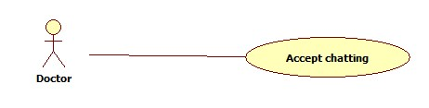

### 3.2.2.5.2. Use Case-1 Specification

|  |  |  |  |  |
| --- | --- | --- | --- | --- |
| **USE CASE - 5 SPECIFICATION** | | | | |
| **Use-case No.** | UC_005 | **Use-case Version** | | **1.0** |
| **Use-case Name** | Accept chatting | | | |
| **Author** | DanhTC | | | |
| **Date** | 30/05/2014 | **Priority** | Normal | |
| **Actor:** Doctor  **Summary:** This use case is doctor accept chatting.  **Goal:** Doctor can accept chatting to chat with patient.  **Triggers:** Doctor clicks “Accept chatting**”** button on **Doctor Profile** page.  **Preconditions:** User must be logged - in as “Doctor” and have request chatting.  **Post-Conditions:** Accept chatting with patient  **Main Success Scenario:**   |  |  |  | | --- | --- | --- | | Step | Actor Action | System Response | | 1 | User logged – in as “Doctor” and clicks “Accept chatting” button on **Doctor Profile** page. |  | | 2 |  | Display window chat to chat with patient request. |   **Alternative Scenario:** N/A  **Exception:**   * When internet connection has problem, the system will ask user for trying again.   **Relationship:** N/A  **Business Rules:** N/A | | | | |

### 3.2.2.6. Functional Requirement 6 – Show Webcam

### 3.2.2.6.1. Use Case-6 Diagram

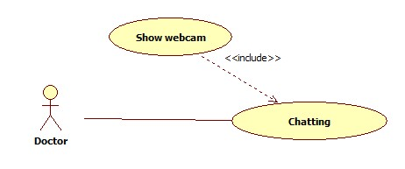

### 3.2.2.6.2. Use Case-6 Specification

|  |  |  |  |  |
| --- | --- | --- | --- | --- |
| **USE CASE - 4 SPECIFICATION** | | | | |
| **Use-case No.** | UC_006 | **Use-case Version** | | **1.0** |
| **Use-case Name** | Show Webcam | | | |
| **Author** | DanhTC | | | |
| **Date** | 30/05/2014 | **Priority** | Normal | |
| **Actor:** Doctor  **Summary:** This use case is show webcam.  **Goal:** Doctor can request showing webcam.  **Triggers:** Patient clicks “Webcam**”** button on **chatting window**.  **Preconditions:** User must logging - in as “Doctor”.  **Post-Conditions:** Show webcam successfully.  **Main Success Scenario:**   |  |  |  | | --- | --- | --- | | Step | Actor Action | System Response | | 1 | User logging – in as Doctor and clicks “Webcam” button on chatting windows with patient. |  | | 2 |  | Send request into patient. | | 3 | Patient denies/accepts request |  | | 4 |  | If patient click “Accept”, webcam will be showed to doctor.  If patient click “Denied”, display message “User denied webcam”. |   **Alternative Scenario:** N/A  **Exception:**   * When internet connection has problem, the system will ask user for trying again.   **Relationship:** N/A  **Business Rules:** N/A | | | | |

### 3.2.2.7. Functional Requirement 7 – Upload Attachment

### 3.2.2.7.1. Use Case-7 Diagram

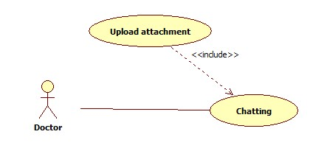

### 3.2.2.7.2. Use Case-7 Specification

|  |  |  |  |  |
| --- | --- | --- | --- | --- |
| **USE CASE - 5 SPECIFICATION** | | | | |
| **Use-case No.** | UC_007 | **Use-case Version** | | **1.0** |
| **Use-case Name** | Upload Attachment | | | |
| **Author** | DanhTC | | | |
| **Date** | 29/05/2014 | **Priority** | Normal | |
| **Actor:** Doctor  **Summary:** This use case is doctor upload attachment.  **Goal:** Doctor can upload attachment.  **Triggers:** Doctor clicks “Upload**”** button on **chatting window**.  **Preconditions:** User must logging - in as “Doctor”.  **Post-Conditions:** Upload successfully.  **Main Success Scenario:**   |  |  |  | | --- | --- | --- | | Step | Actor Action | System Response | | 1 | User logins with role patient and clicks “Upload” button on **chatting window**. |  | | 2 |  | Display “Upload” window. This window will include directory file and “Choose file” button to choose file upload, textbox for saved name file. | | 3 | Choose file and input name and click “Upload” button. |  | | 4 |  | If file not attached then display message “No files attached”.  If file attached then upload file into server with two scenario:  If upload successfully, system will display message “Upload successfully”.  If happen errors about system/internet connection, system will display “Upload fail”. |   **Alternative Scenario:** N/A  **Exception:**   * When internet connection has problem, the system will ask user for trying again.   **Relationship:** N/A  **Business Rules:** N/A | | | | |